**Week 1 - S1 – Assignment HW**

**Name: Ramesh Harisabapathi Chettiar**

**Roll Number: RA2411030010263**

**Course: Networking and Communications**

**Semester: 3**

**Date of Submission: 19/08/2025**

**Lab Practice Programs (Any Six)**

**1. An organization took up the exercise to find the Body Mass Index (BMI) of all the persons in**

**a team of 10 members. For this create a program to find the BMI and display the height,**

**weight, BMI, and status of each individual**

**Hint =>**

**a. Take user input for the person's weight (kg) and height (cm) and store it in the**

**corresponding 2D array of 10 rows. The First Column stores the weight and the second**

**column stores the height in cm**

**b. Create a Method to find the BMI and status of every person given the person's height**

**and weight and return the 2D String array. Use the formula BMI = weight / (height \***

**height). Note unit is kg/m^2. For this convert cm to meter**

**c. Create a Method that takes the 2D array of height and weight as parameters. Calls the**

**user-defined method to compute the BMI and the BMI Status and stores in a 2D String**

**array of height, weight, BMI, and status.**

**d. Create a method to display the 2D string array in a tabular format of Person's Height,**

**Weight, BMI, and the Status**

**e. Finally, the main function takes user inputs, calls the user-defined methods, and displays**

**the result.**

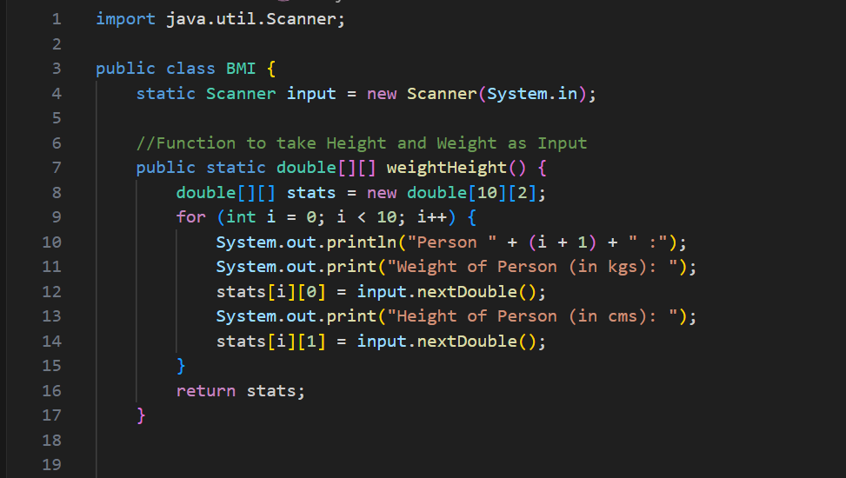 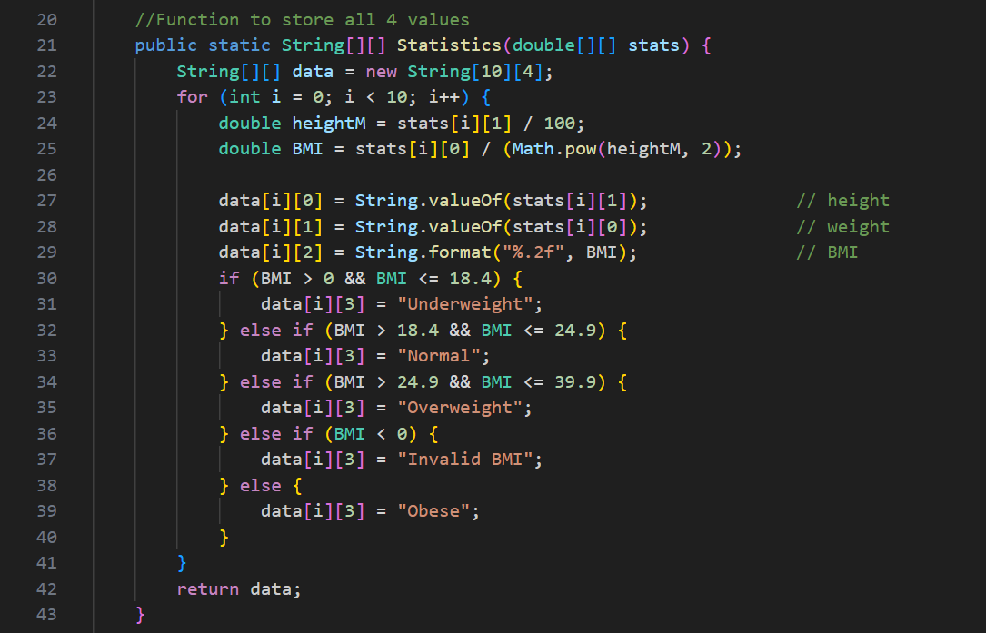 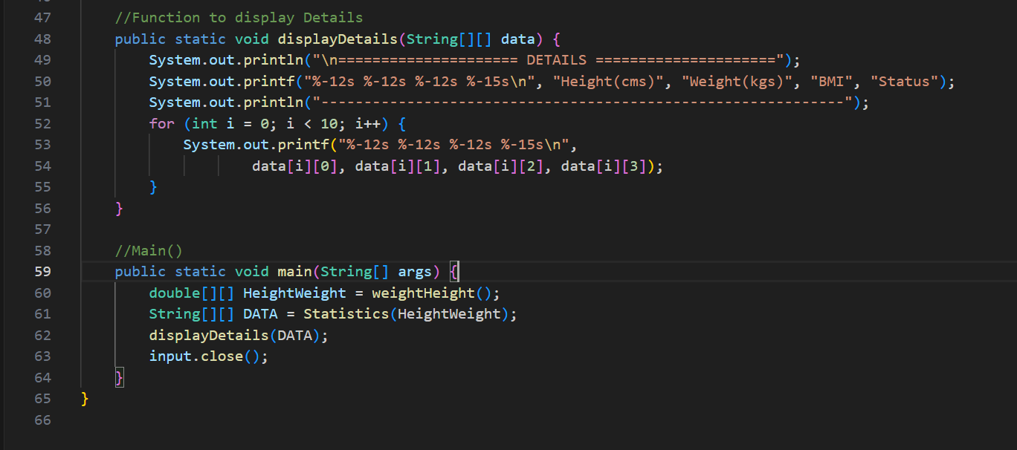

**2. Find unique characters in a string using the charAt() method and display the result**

**Hint =>**

**a. Create a Method to find the length of the text without using the String method length()**

**b. Create a method to Find unique characters in a string using the charAt() method and**

**return them as a 1D array. The logic used here is as follows:**

**i. Create an array to store the unique characters in the text. The size is the length of**

**the text**

**ii. Loops to Find the unique characters in the text. Find the unique characters in the text**

**using a nested loop. An outer loop iterates through each character and an inner loop**

**checks if the character is unique by comparing it with the previous characters. If the**

**character is unique, it is stored in the result array**

**iii. Create a new array to store the unique characters**

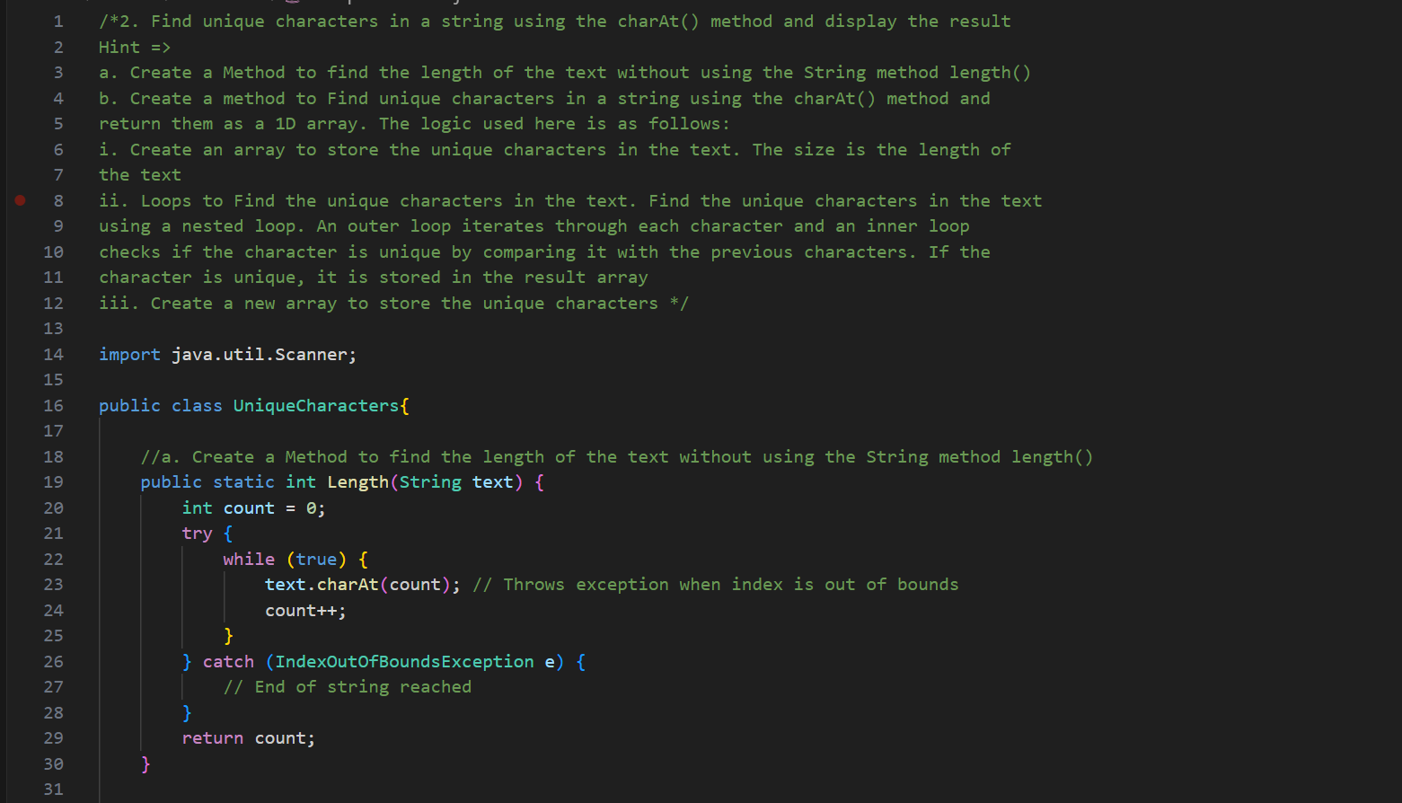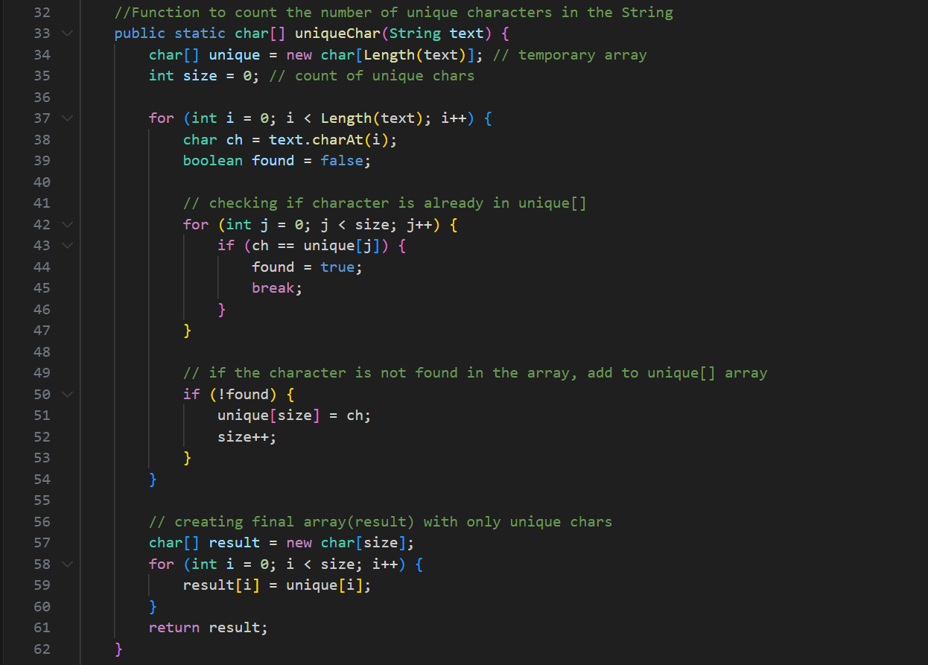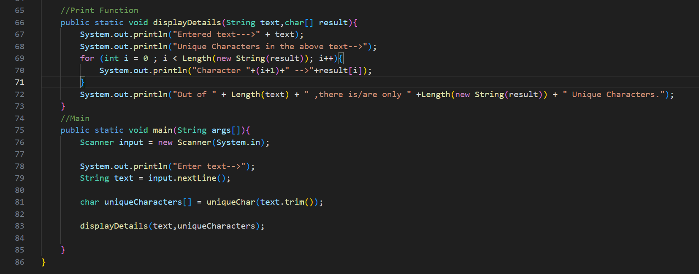

**OUTPUT-**

